**Meeting June 30**

Climatic Controls:

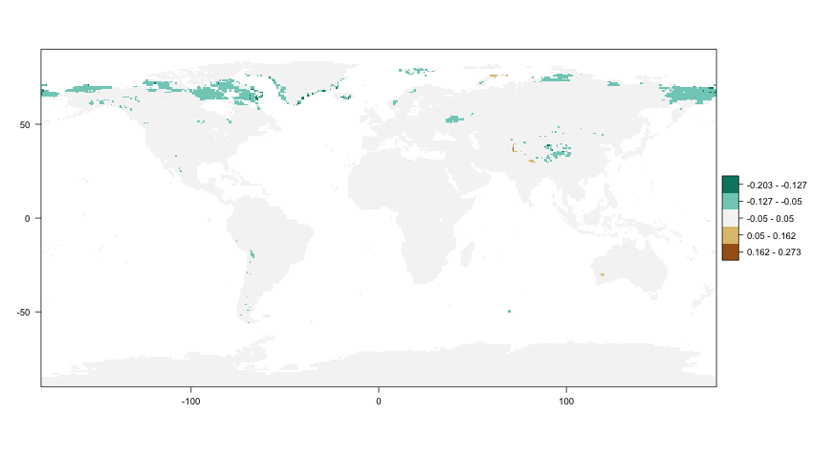

Changes in Moisture CC over 30 years for second half of September

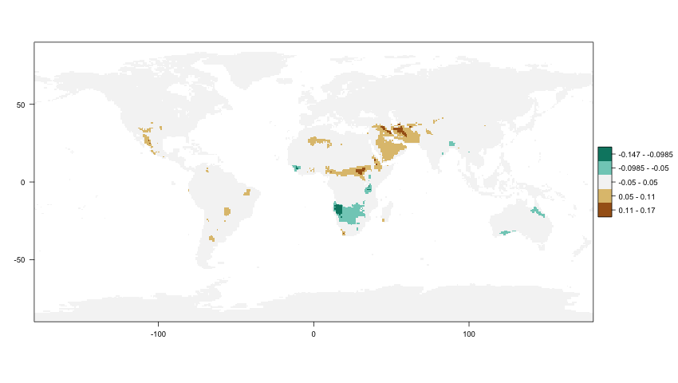

Changes in Temperature CC over 30 years for first half of April

Climatic Controls connected to Phenology:

Extract climatic controls